**Pointers in CPP –**

#include <bits/stdc++.h>

// #include <iostream>

// #include<algorithm>

// #include<climits>

// #include<string>

// #include<cctype>

// #include<vector>

// #include<set>

using namespace std;

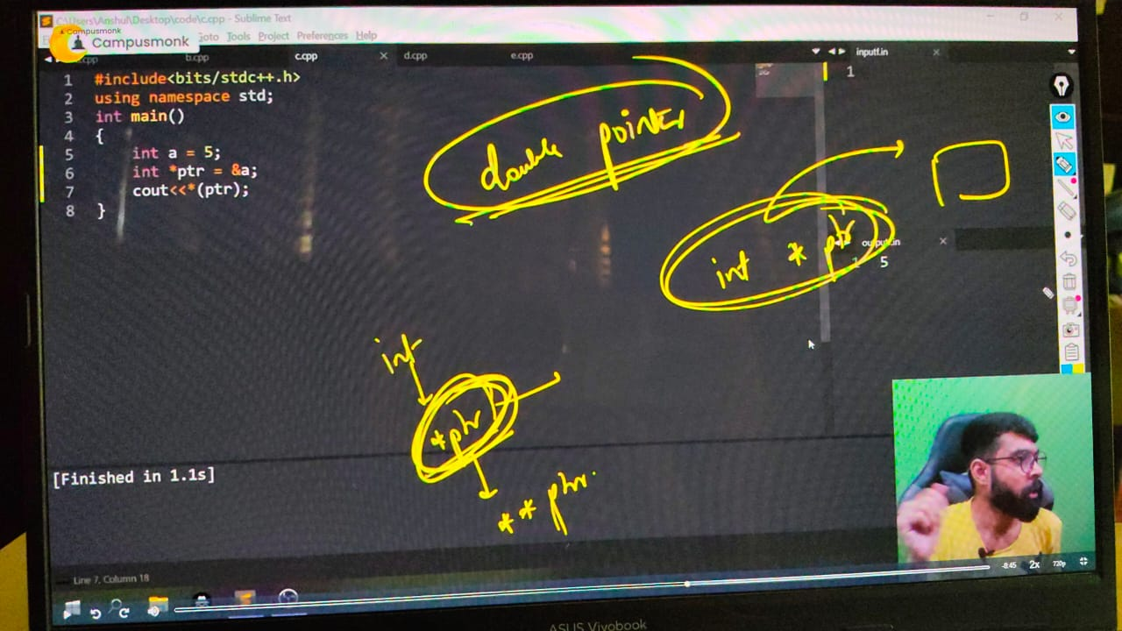

// int main()

// {

// Pointers in cpp - Pointers are basically used to store the addrss of a variable in the memory. For all diffrerent datatypes basically different pointers are declared and it stores its value in the memory along with the address.

**// Initialization of a Pointer -**

// int a = 5;

// int *ptr = &a;

// cout << ptr << endl; // 0x61ff08

// // Note - once we've declared the pointer then no need to use * again and again. it can directl beused using the name of pointer fro nextonwards

// int b = 10;

// int *ptr1;

// ptr1 = &b;

// cout << ptr1 << endl; // 0x61ff00

// // by using the pointer name we're here printing the address(&) of that pointer variable

// //  But foir printing the value inside that pointer we need to use (). : & -> address. of

// //  But foir printing the value inside that pointer we need to use (*).: * -> value at

// cout << *ptr << endl;  // 5

// cout << *ptr1 << endl; // 10

**// // Double Pointer**  - this Approach is  uses for store and print the addrss of a pointer. Means pointer ka pointer. which is Pointer of Pointer

// int c = 15;

// int *ptr2 = &a;

// int **ptr3 = &ptr2;

// cout << *ptr2 << endl;//5

// cout << ptr2 << endl;//0x61fefc

// cout << *ptr3 << endl;//0x61fefc

// cout << ptr3 << endl;//0x61fef4

// cout << **ptr3 << endl;//5

// *ptr2 = 75;

// cout<<**ptr3<<endl;//75

// // Understanding of pointer with an array -

// int n=5;

// int arr[5] = {2,4,6,8,10};

// cout<<arr<<endl;//x61fedc - addrss of array stord in the memory

// cout<<(arr+1)<<endl;//0x61fee0 - address of  any element which we want

// // printing elements throgh pointer in array -

// cout<<*arr<<endl;//2

// cout<<*(arr+1)<<endl;//4

// }

// ____________ ____________ ____________ ____________ ____________